**9-18-23 notes**

Fundamentals of Programming with VBA

Tools of programming:

* Conditionals (If/Then)
* Iterations (Repeats/loops)
* Functions (Actions)
* Variables/Arrays (Data that is being manipulated)
  + Variables are a single value that is stored
  + Arrays hold multiple values
  + 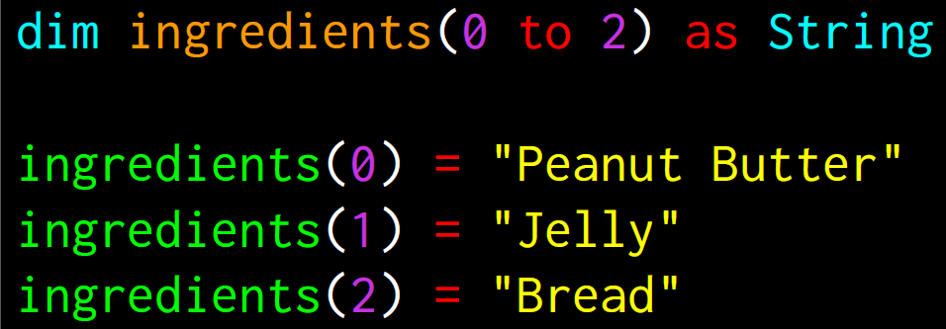

VBA:

Dim is short for Dimension

Variable declaration is telling the computer what kind of data can be stored (like a data input mask)

* Int is integer, double is digit with 2 spaces after the decimal point

Variable assignment can store a fixed value (Numerical or text), or a changing value (ie- count of iteration)

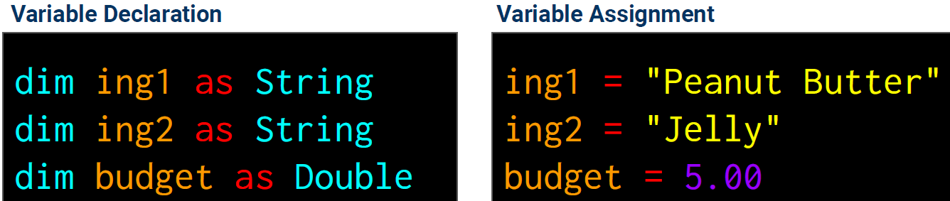

Syntax of a language is the grammar of the language

Object oriented programming has reusable code (helper code)

* Back in the day there was just linear programming
* And then came along functional programming too

Sub stands for Subroutine

Hello World!

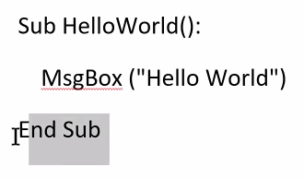

Making a new macro in a sheet:

Developer tab in ribbon, Visual Basic button on Left, Double-click the project you want to add script to, it’ll open up a box within the window where you can type or copy/paste the VB code you want to add.

Cells and Ranges: 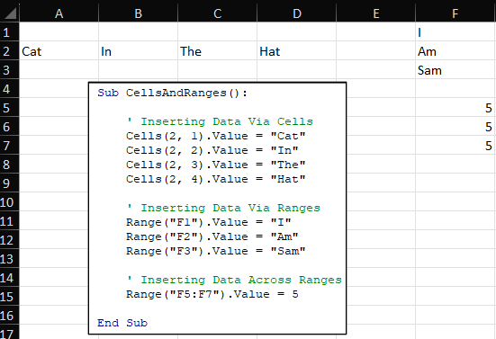

You can also define a range (Select cells and name in upper left corner of cell A1) and use it instead of F5:F7

**Know the logic.**

**Syntax changes language to language. Logic and Steps don’t really change.**

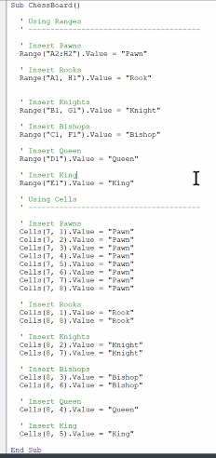

Variables:

Concatenation is a word for Combination

Basic string variable- Assigns the text “Gandalf” as name.

* You can edit the name at the top without having to edit every reference in the code

Fullname combines name, a comma space, and title as one unit,

MsgBox(fullname) displays the value of fullname

MsgBox (“I am ” + str(age1) + “ years old.”) requires age1 to be converted from numerical to string, which is why the code uses casting to convert it [declaring str(age1)]

Boolean stores true/false

Variable money_grows_on_trees supplies a value of false

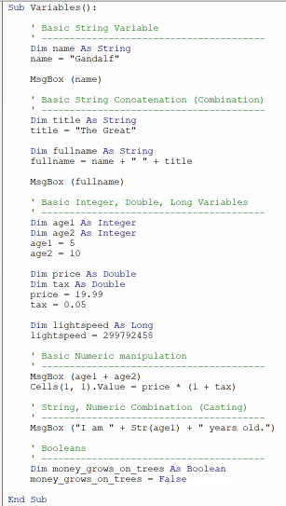

Total calculator solutions:

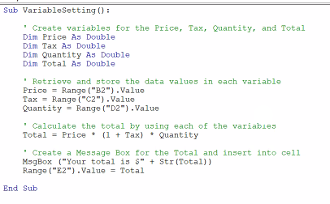

Arrays:

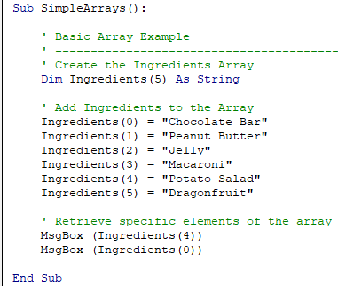

(#) qualifies a title to become an array

In example above, the number 5 designates the size of the array (1x5)

VBA requires a number in there to designate the size of the array. Python does not.

Splitting arrays:

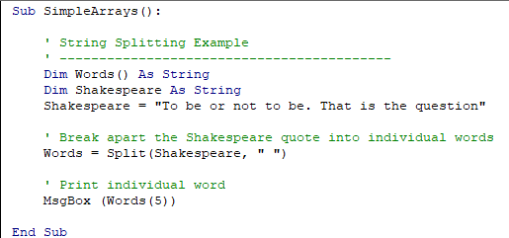

In example above, “To” is words(0), “be” is words(1) “or” is words(2)

Split command splits the string into new units in the array.

MsgBox (Words(*n*)) makes a popup box that says the *n*th word

Reg-Ex is a powerful word searching tool. (IE- big brother spying on your public posts online)

Sentiment analysis- A task asking what words have people used most, and what is the general sentiment associated with the use of the word.

Datasense is a tool for predicting behavior (ie: what will a person buy)

Conditionals:

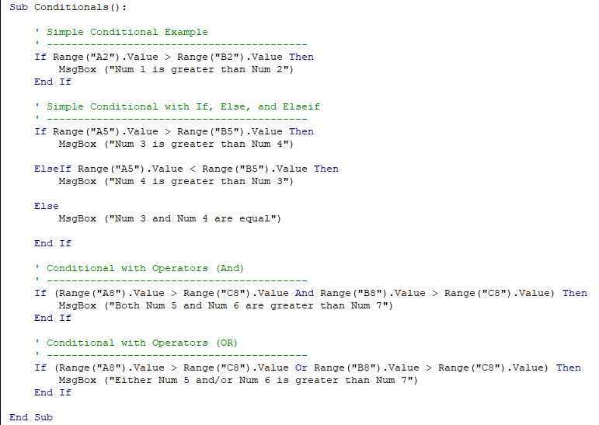

ElseIf can be chained one after another into infinity. End with EndIf

